CHAPTER 1

INTRODUCTION TO IMAGE PROCESSING

**INTRODUCTION**

**1.1 IMAGE:**

An image is a two-dimensional picture, which has a similar appearance to some subject usually a physical object or a person.

Image is a two-dimensional, such as a photograph, screen display, and as well as a three-dimensional, such as a statue. They may be captured by optical devices—such as cameras, mirrors, lenses, telescopes, microscopes, etc. and natural objects and phenomena, such as the human eye or water surfaces.

The word image is also used in the broader sense of any two-dimensional figure such as a map, a graph, a pie chart, or an abstract painting. In this wider sense, images can also be rendered manually, such as by drawing, painting, carving, rendered automatically by printing or computer graphics technology, or developed by a combination of methods, especially in a pseudo-photograph.

 

**Fig**

An image is a rectangular grid of pixels. It has a definite height and a definite width counted in pixels. Each pixel is square and has a fixed size on a given display. However different computer monitors may use different sized pixels. The pixels that constitute an image are ordered as a grid (columns and rows); each pixel consists of numbers representing magnitudes of brightness and color.

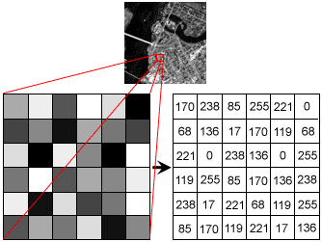

**Fig 1.1**

Each pixel has a color. The color is a 32-bit integer. The first eight bits determine the redness of the pixel, the next eight bits the greenness, the next eight bits the blueness, and the remaining eight bits the transparency of the pixel.

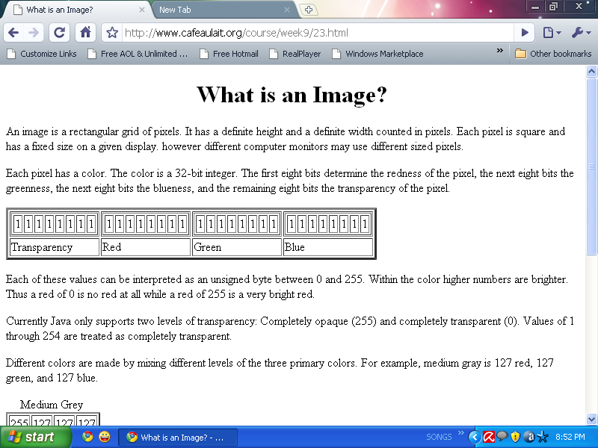

**Fig**

**1.2 IMAGE FILE SIZES:**

Image file size is expressed as the number of bytes that increases with the number of pixels composing an image, and the color depth of the pixels. The greater the number of rows and columns, the greater the image resolution, and the larger the file. Also, each pixel of an image increases in size when its color depth increases, an 8-bit pixel (1 byte) stores 256 colors, a 24-bit pixel (3 bytes) stores 16 million colors, the latter known as true color.

Image compression uses algorithms to decrease the size of a file. High resolution cameras produce large image files, ranging from hundreds of kilobytes to megabytes, per the camera's resolution and the image-storage format capacity. High resolution digital cameras record 12 megapixel (1MP = 1,000,000 pixels / 1 million) images, or more, in true color. For example, an image recorded by a 12 MP camera; since each pixel uses 3 bytes to record true color, the uncompressed image would occupy 36,000,000 bytes of memory, a great amount of digital storage for one image, given that cameras must record and store many images to be practical. Faced with large file sizes, both within the camera and a storage disc, image file formats were developed to store such large images.

**1.3 IMAGE FILE FORMATS:**

Image file formats are standardized means of organizing and storing images. This entry is about digital image formats used to store photographic and other images. Image files are composed of either pixel or vector (geometric) data that are rasterized to pixels when displayed (with few exceptions) in a vector graphic display. Including proprietary types, there are hundreds of image file types. The PNG, JPEG, and GIF formats are most often used to display images on the Internet.

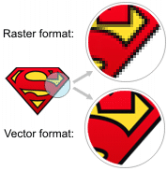

**Fig**

In addition to straight image formats, Metafile formats are portable formats which can include both raster and vector information. The metafile format is an intermediate format. Most Windows applications open metafiles and then save them in their own native format.

**1.3.1 RASTER FORMATS:**

These formats store images as bitmaps (also known as pixmaps).

* **JPEG/JFIF:**

JPEG (Joint Photographic Experts Group) is a compression method. JPEG compressed images are usually stored in the JFIF (JPEG File Interchange Format) file format. JPEG compression is lossy compression. Nearly every digital camera can save images in the JPEG/JFIF format, which supports 8 bits per color (red, green, blue) for a 24-bit total, producing relatively small files. Photographic images may be better stored in a lossless non-JPEG format if they will be re-edited, or if small "artifacts" are unacceptable. The JPEG/JFIF format also is used as the image compression algorithm in many Adobe PDF files.

* **EXIF:**

The EXIF (Exchangeable image file format) format is a file standard similar to the JFIF format with TIFF extensions. It is incorporated in the JPEG writing software used in most cameras. Its purpose is to record and to standardize the exchange of images with image metadata between digital cameras and editing and viewing software. The metadata are recorded for individual images and include such things as camera settings, time and date, shutter speed, exposure, image size, compression, name of camera, color information, etc. When images are viewed or edited by image editing software, all of this image information can be displayed.

* **TIFF:**

The TIFF (Tagged Image File Format) format is a flexible format that normally saves 8 bits or 16 bits per color (red, green, blue) for 24-bit and 48-bit totals, respectively, usually using either the TIFF or TIF filename extension. TIFFs are lossy and lossless. Some offer relatively good lossless compression for bi-level (black & white) images. Some digital cameras can save in TIFF format, using the LZW compression algorithm for lossless storage. TIFF image format is not widely supported by web browsers. TIFF remains widely accepted as a photograph file standard in the printing business. TIFF can handle device-specific color spaces, such as the CMYK defined by a particular set of printing press inks.

* **PNG:**

The PNG (Portable Network Graphics) file format was created as the free, open-source successor to the GIF. The PNG file format supports true color (16 million colors) while the GIF supports only 256 colors. The PNG file excels when the image has large, uniformly colored areas. The lossless PNG format is best suited for editing pictures, and the lossy formats, like JPG, are best for the final distribution of photographic images, because JPG files are smaller than PNG files. PNG, an extensible file format for the lossless, portable, well-compressed storage of raster images. PNG provides a patent-free replacement for GIF and can also replace many common uses of TIFF. Indexed-color, grayscale, and true color images are supported, plus an optional alpha channel. PNG is designed to work well in online viewing applications, such as the World Wide Web. PNG is robust, providing both full file integrity checking and simple detection of common transmission errors.

* **GIF:**

GIF (Graphics Interchange Format) is limited to an 8-bit palette, or 256 colors. This makes the GIF format suitable for storing graphics with relatively few colors such as simple diagrams, shapes, logos and cartoon style images. The GIF format supports animation and is still widely used to provide image animation effects. It also uses a lossless compression that is more effective when large areas have a single color, and ineffective for detailed images or dithered images.

* **BMP:**

The BMP file format (Windows bitmap) handles graphics files within the Microsoft Windows OS. Typically, BMP files are uncompressed, hence they are large. The advantage is their simplicity and wide acceptance in Windows programs.

**1.3.2 VECTOR FORMATS:**

As opposed to the raster image formats above (where the data describes the characteristics of each individual pixel), vector image formats contain a geometric description which can be rendered smoothly at any desired display size.

At some point, all vector graphics must be rasterized in order to be displayed on digital monitors. However, vector images can be displayed with analog CRT technology such as that used in some electronic test equipment, medical monitors, radar displays, laser shows and early video games. Plotters are printers that use vector data rather than pixel data to draw graphics.

* **CGM:**

CGM (Computer Graphics Metafile) is a file format for 2D vector graphics, raster graphics, and text. All graphical elements can be specified in a textual source file that can be compiled into a binary file or one of two text representations. CGM provides a means of graphics data interchange for computer representation of 2D graphical information independent from any particular application, system, platform, or device.

* **SVG:**

SVG (Scalable Vector Graphics) is an open standard created and developed by the World Wide Web Consortium to address the need for a versatile, scriptable and all purpose vector format for the web and otherwise. The SVG format does not have a compression scheme of its own, but due to the textual nature of XML, an SVG graphic can be compressed using a program such as gzip.

**1.4 IMAGE PROCESSING:**

Digital image processing, the manipulation of images by computer, is relatively recent development in terms of man’s ancient fascination with visual stimuli. In its short history, it has been applied to practically every type of images with varying degree of success. The inherent subjective appeal of pictorial displays attracts perhaps a disproportionate amount of attention from the scientists and also from the layman. Digital image processing like other glamour fields, suffers from myths, mis-connect ions, mis-understandings and mis-information. It is vast umbrella under which fall diverse aspect of optics, electronics, mathematics, photography graphics and computer technology. It is truly multidisciplinary endeavor ploughed with imprecise jargon.

Several factor combine to indicate a lively future for digital image processing. A major factor is the declining cost of computer equipment. Several new technological trends promise to further promote digital image processing. These include parallel processing mode practical by low cost microprocessors, and the use of charge coupled devices (CCDs) for digitizing, storage during processing and display and large low cost of image storage arrays.

**1.5 FUNDAMENTAL STEPS IN DIGITAL IMAGE PROCESSING:**

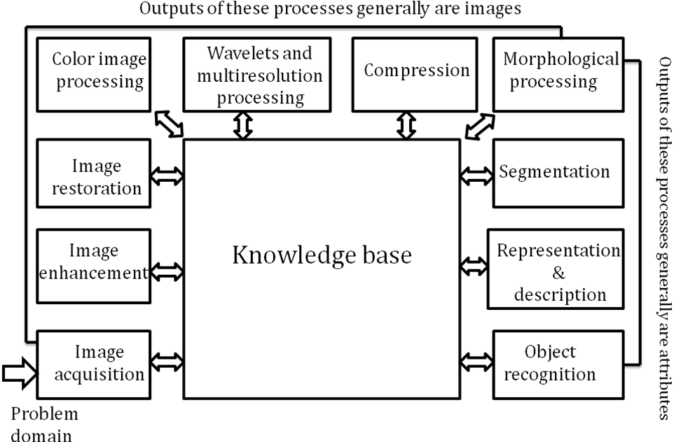**Fig**

**1.5.1 Image Acquisition:**

**Image Acquisition** is to acquire a digital image. To do so requires an image sensor and the capability to digitize the signal produced by the sensor. The sensor could be monochrome or color TV camera that produces an entire image of the problem domain every 1/30 sec. the image sensor could also be line scan camera that produces a single image line at a time. In this case, the objects motion past the line.

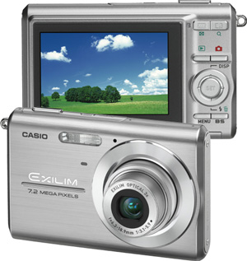

**Fig**

Scanner produces a two-dimensional image. If the output of the camera or other imaging sensor is not in digital form, an analog to digital converter digitizes it. The nature of the sensor and the image it produces are determined by the application.

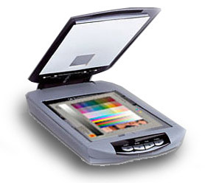

**Fig**

**1.5.2 Image Enhancement:**

**Image enhancement**is among the simplest and most appealing areas of digital image processing. Basically, the idea behind enhancement techniques is to bring out detail that is obscured, or simply to highlight certain features of interesting an image. A familiar example of enhancement is when we increase the contrast of an image because “it looks better.” It is important to keep in mind that enhancement is a very subjective area of image processing.

  
**Fig**

**1.5.3 Image restoration:**

**Image restoration**is an area that also deals with improving the appearance of an image. However, unlike enhancement, which is subjective, image restoration is objective, in the sense that restoration techniques tend to be based on mathematical or probabilistic models of image degradation.

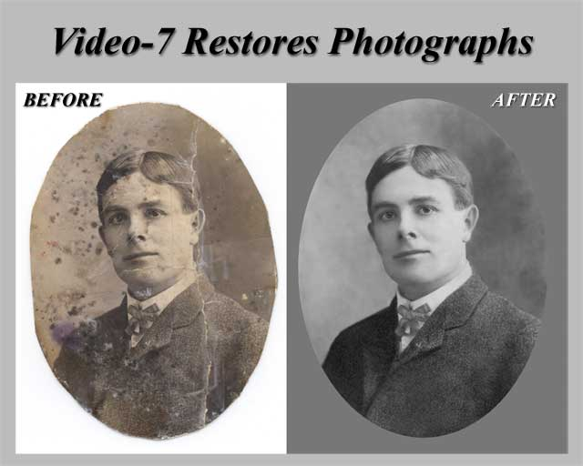

**Fig**

Enhancement, on the other hand, is based on human subjective preferences regarding what constitutes a “good” enhancement result. For example, contrast stretching is considered an enhancement technique because it is based primarily on the pleasing aspects it might present to the viewer, where as removal of image blur by applying a deblurring function is considered a restoration technique.

**1.5.4 Color image processing:**

The use of color in image processing is motivated by two principal factors. First, color is a powerful descriptor that often simplifies object identification and extraction from a scene. Second, humans can discern thousands of color shades and intensities, compared to about only two dozen shades of gray. This second factor is particularly important in manual image analysis.

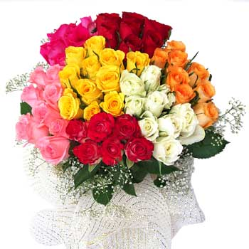

**Fig**

**1.5.5 Wavelets and multiresolution processing:**

**Wavelets** are the formation for representing images in various degrees of resolution. Although the Fourier transform has been the mainstay of transform based image processing since the late1950’s, a more recent transformation, called the wavelet transform, and is now making it even easier to compress, transmit, and analyze many images. Unlike the Fourier transform, whose basis functions are sinusoids, wavelet transforms are based on small values, called Wavelets, of varying frequency and limited duration.

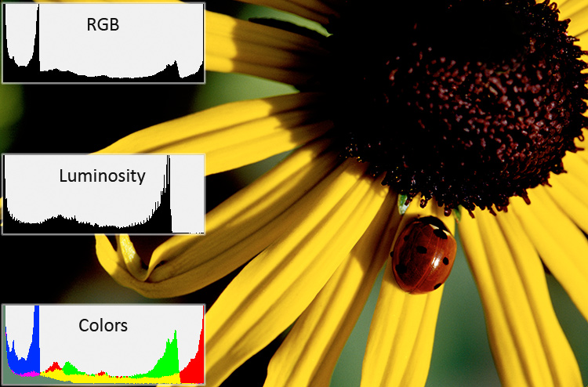

**Fig**

Wavelets were first shown to be the foundation of a powerful new approach to signal processing and analysis called **Multiresolution** theory. Multiresolution theory incorporates and unifies techniques from a variety of disciplines, including sub band coding from signal processing, quadrature mirror filtering from digital speech recognition, and pyramidal image processing.

**1.5.6 Compression:**

**Compression**, as the name implies, deals with techniques for reducing the storage required saving an image, or the bandwidth required for transmitting it. Although storage technology has improved significantly over the past decade, the same cannot be said for transmission capacity. This is true particularly in uses of the Internet, which are characterized by significant pictorial content. Image compression is familiar to most users of computers in the form of image file extensions, such as the jpg file extension used in the JPEG (Joint Photographic Experts Group) image compression standard.

**1.5.7 Morphological processing:**

**Morphological processing**deals with tools for extracting image components that are useful in the representation and description of shape. The language of mathematical morphology is set theory. As such, morphology offers a unified and powerful approach to numerous image processing problems. Sets in mathematical morphology represent objects in an image. For example, the set of all black pixels in a binary image is a complete morphological description of the image.

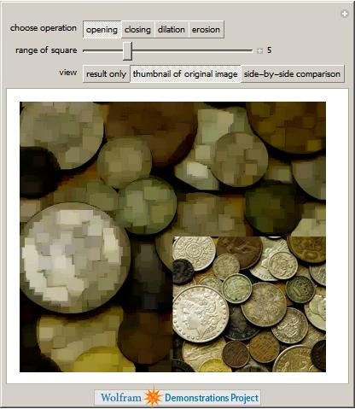

**Fig**

In binary images, the sets in question are members of the 2-D integer space Z2, where each element of a set is a 2-D vector whose coordinates are the (x,y) coordinates of a black(or white) pixel in the image. Gray-scale digital images can be represented as sets whose components are in Z3. In this case, two components of each element of the set refer to the coordinates of a pixel, and the third corresponds to its discrete gray-level value.

**1.5.8 Segmentation:**

**Segmentation**procedures partition an image into its constituent parts or objects. In general, autonomous segmentation is one of the most difficult tasks in digital image processing. A rugged segmentation procedure brings the process a long way toward successful solution of imaging problems that require objects to be identified individually.

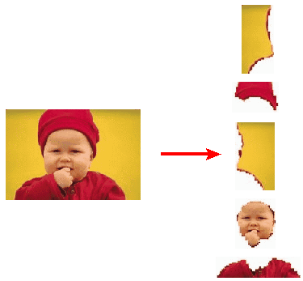

**Fig**

On the other hand, weak or erratic segmentation algorithms almost always guarantee eventual failure. In general, the more accurate the segmentation, the more likely recognition is to succeed.

**1.5.9 Representation and description:**

Representation and description almost always follow the output of a segmentation stage, which usually is raw pixel data, constituting either the boundary of a region (i.e., the set of pixels separating one image region from another) or all the points in the region itself. In either case, converting the data to a form suitable for computer processing is necessary. The first decision that must be made is whether the data should be represented as a boundary or as a complete region. Boundary representation is appropriate when the focus is on external shape characteristics, such as corners and inflections.

Regional representation is appropriate when the focus is on internal properties, such as texture or skeletal shape. In some applications, these representations complement each other. Choosing a representation is only part of the solution for transforming raw data into a form suitable for subsequent computer processing. A method must also be specified for describing the data so that features of interest are highlighted. Description, also called feature selection, deals with extracting attributes that result in some quantitative information of interest or are basic for differentiating one class of objects from another.

**1.5.10 Object recognition:**

The last stage involves recognition and interpretation. Recognition is the process that assigns a label to an object based on the information provided by its descriptors. Interpretation involves assigning meaning to an ensemble of recognized objects.

**1.5.11 Knowledgebase:**

Knowledge about a problem domain is coded into image processing system in the form of a knowledge database. This knowledge may be as simple as detailing regions of an image when the information of interests is known to be located, thus limiting the search that has to be conducted in seeking that information. The knowledge base also can be quite complex, such as an inter related to list of all major possible defects in a materials inspection problem or an image data base containing high resolution satellite images of a region in connection with change deletion application. In addition to guiding the operation of each processing module, the knowledge base also controls the interaction between modules. The system must be endowed with the knowledge to recognize the significance of the location of the string with respect to other components of an address field. This knowledge glides not only the operation of each module, but it also aids in feedback operations between modules through the knowledge base. We implemented preprocessing techniques using MATLAB.

**1.6 COMPONENTS OF AN IMAGE PROCESSING SYSTEM:**

As recently as the mid-1980s, numerous models of image processing systems being sold throughout the world were rather substantial peripheral devices that attached to equally substantial host computers. Late in the 1980s and early in the 1990s, the market shifted to image processing hardware in the form of single boards designed to be compatible with industry standard buses and to fit into engineering workstation cabinets and personal computers. In addition to lowering costs, this market shift also served as a catalyst for a significant number of new companies whose specialty is the development of software written specifically for image processing.

**Fig**

Although large-scale image processing systems still are being sold for massive imaging applications, such as processing of satellite images, the trend continues toward miniaturizing and blending of general-purpose small computers with specialized image processing hardware. Figure 1.24 shows the basic components comprising a typical general-purpose system used for digital image processing. The function of each component is discussed in the following paragraphs, starting with image sensing.

* **Image sensors:**

With reference to sensing, two elements are required to acquire digital images. The first is a physical device that is sensitive to the energy radiated by the object we wish to image. The second, called a digitizer, is a device for converting the output of the physical sensing device into digital form. For instance, in a digital video camera, the sensors produce an electrical output proportional to light intensity. The digitizer converts these outputs to digital data.

* **Specialized image processing hardware:**

Specialized image processing hardware usually consists of the digitizer just mentioned, plus hardware that performs other primitive operations, such as an arithmetic logic unit (ALU), which performs arithmetic and logical operations in parallel on entire images. One example of how an ALU is used is in averaging images as quickly as they are digitized, for the purpose of noise reduction. This type of hardware sometimes is called a front-end subsystem, and its most distinguishing characteristic is speed. In other words, this unit performs functions that require fast data throughputs (e.g., digitizing and averaging video images at 30 frames) that the typical main computer cannot handle.

* **Computer:**

The computer in an image processing system is a general-purpose computer and can range from a PC to a supercomputer. In dedicated applications, sometimes specially designed computers are used to achieve a required level of performance, but our interest here is on general-purpose image processing systems. In these systems, almost any well-equipped PC-type machine is suitable for offline image processing tasks.

* **Image processing software:**

Software for image processing consists of specialized modules that perform specific tasks. A well-designed package also includes the capability for the user to write code that, as a minimum, utilizes the specialized modules. More sophisticated software packages allow the integration of those modules and general-purpose software commands from at least one computer language.

* **Mass storage:**

Mass storage capability is a must in image processing applications. An image of size 1024*1024 pixels, in which the intensity of each pixel is an 8-bit quantity, requires one megabyte of storage space if the image is not compressed. When dealing with thousands, or even millions, of images, providing adequate storage in an image processing system can be a challenge. Digital storage forimage processing applications fall into three principal categories: (1) short-term storage for use during processing, (2) on-line storage for relatively fast recall, and (3) archival storage, characterized by infrequent access. Storage is measured in bytes (eight bits), Kbytes (one thousand bytes), Mbytes (one million bytes), Gbytes (meaning giga, or one billion, bytes), and Tbytes (meaning tera, or one trillion, bytes).

One method of providing short-term storage is computer memory. Another is by specialized boards, called frame buffers that store one or more images and can be accessed rapidly, usually at video rates. The latter method allows virtually instantaneous image zoom, as well as scroll (vertical shifts) and pan (horizontal shifts). Frame buffers usually are housed in the specialized image processing hardware unit shown in Fig. 1.24. Online storage generally takes the form of magnetic disks or optical-media storage. The key factor characterizing on-line storage is frequent access to the stored data. Finally, archival storage is characterized by massive storage requirements but infrequent need for access. Magnetic tapes and optical disks housed in “jukeboxes” are the usual media for archival applications.

* **Image displays:**

Image displays in use today are mainly color (preferably flat screen) TV monitors. Monitors are driven by the outputs of image and graphics display cards that are an integral part of the computer system. Seldom are there requirements for image display applications that cannot be met by display cards available commercially as part of the computer system. In some cases, it is necessary to have stereo displays, and these are implemented in the form of headgear containing two small displays embedded in goggles worn by the user.

* **Hardcopy:**

Hardcopy devices for recording images include laser printers, film cameras, heat-sensitive devices, inkjet units, and digital units, such as optical and CD-ROM disks. Film provides the highest possible resolution, but paper is the obvious medium of choice for written material. For presentations, images are displayed on film transparencies or in a digital medium if image projection equipment is used. The latter approach is gaining acceptance as the standard for image presentations.

* **Network:**

Networking is almost a default function in any computer system in use today. Because of the large amount of data inherent in image processing applications, the key consideration in image transmission is bandwidth. In dedicated networks, this typically is not a problem, but communications with remote sites via the Internet are not always as efficient. Fortunately, this situation is improving quickly as a result of optical fiber and other broadband technologies.